**Temporal trends in VV ECMO utilisation before and during the COVID-19 pandemic: an ELSO registry analysis**

Supplementary Appendix

Ryan Ruiyang Ling, Kollengode Ramanthan, Ying Chen, Ryan P Barbaro, Kiran Shekar, Daniel Brodie, Graeme MacLaren

Table of contents

Supplementary methods 2

Figure S1. STROBE inclusion flowchart 3

Table S1. Trends in centre characteristics over time 4

Table S2. Centre characteristics over time, stratified by ELSO chapter 4

Figure S2. Alluvial plot depicting reporting practices of centres across time periods 5

Figure S3. Trends in centre volume across time periods stratified by ELSO chapter 6

Table S3. Demographics, centre, and pre-ECMO characteristics across the three time periods 7

Table S4. Arterial blood gas before and after ECMO initiation 8

Table S5. Ventilatory parameters before and after ECMO initiation, across time periods 9

Table S6. Pre-ECMO adjunctive therapies 10

Table S7. Unadjusted survival estimates at 90 days after ECMO initiation across time periods, and annually 10

Table S8. Complications while receiving ECMO 11

# Supplementary methods

For continuous variables we reported median (25th-75th percentiles), and for numerical variables, we reported counts and percentages. We compared groups using the chi-squared test for discrete outcomes and the Kruskal-Wallis test for continuous outcomes. We conducted the analysis using RStudio 4.2.2.

For ratios of incidence rates, we first determined the incidence rate of ECMO by taking the number of ECMO runs divided by the number of centres. We then divided the incidence rate of ECMO of one year by the incidence rate of the preceding year. We derived the standard deviation and consequently 95% confidence intervals based on the methods outlined by Suthar et al. 2012. (see reference below).

In order to better understand the incidence rate ratios over time, we used a non-linear modelling method using restricted cubic splines with four knots to describe the trends incidence rate ratios.

# Figure S1. STROBE inclusion flowchart

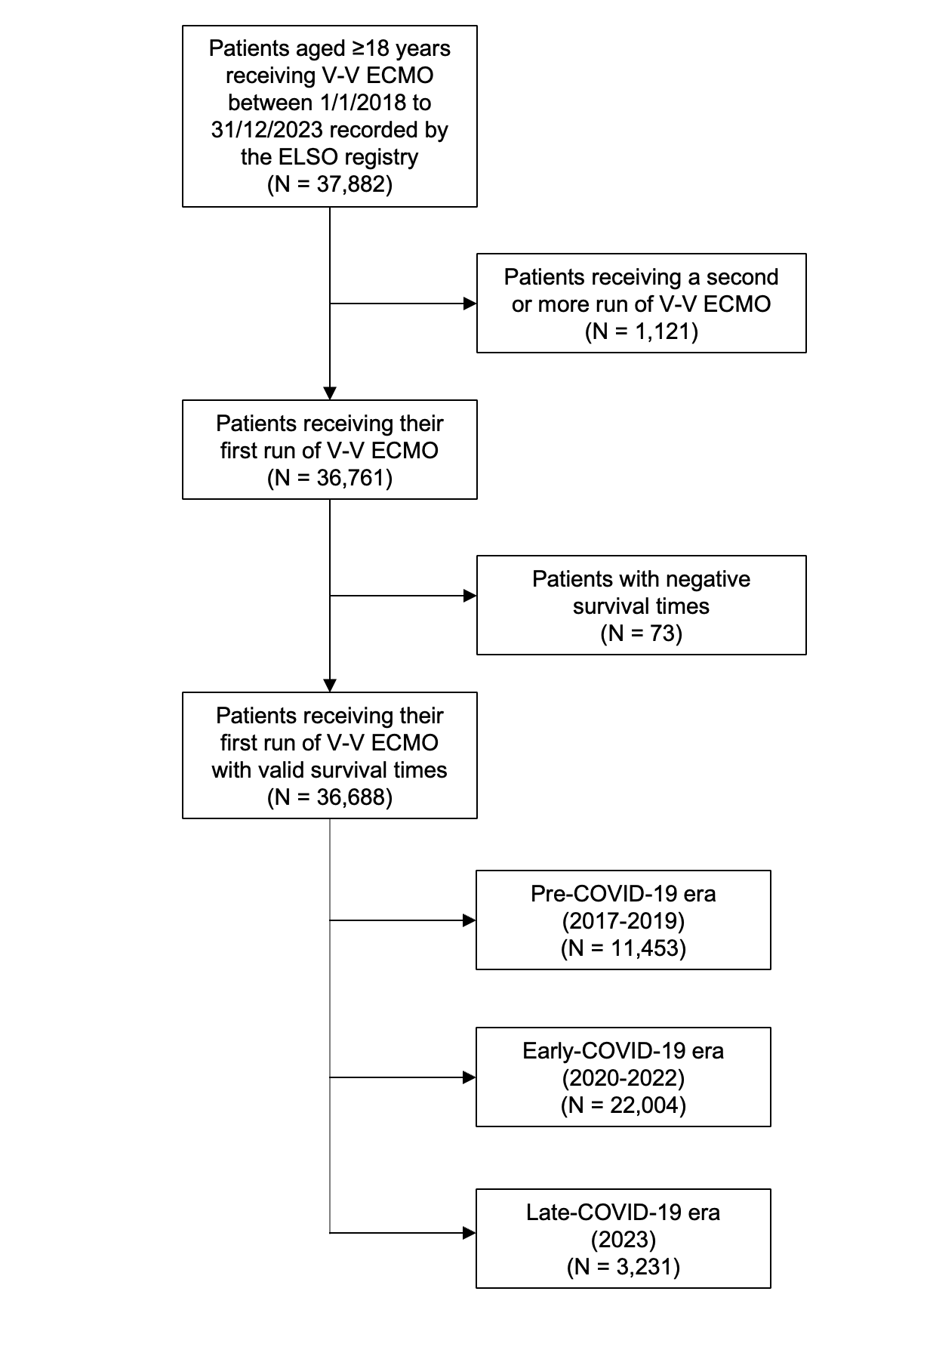

# Table S1. Trends in centre characteristics over time

|  |  |  |  |  |  |  |  |
| --- | --- | --- | --- | --- | --- | --- | --- |
| **Year** | 2017 | 2018 | 2019 | 2020 | 2021 | 2022 | 2023 |
| **Number of centres** | 277 | 315 | 355 | 418 | 469 | 418 | 382 |
| **Centre volume** | 22 (11-39) | 22 (11-40) | 26 (12-44) | 37 (20-63) | 37 (21-65) | 18 (9-32) | 15 (8-26) |
| **Incidence rate ratio** | Ref | 1.03 (0.99-1.08) | 1.08 (1.03-1.13) | 1.44 (1.39-1.49) | 1.04 (1.01-1.07) | 0.46 (0.44-0.48) | 0.84 (0.80-0.88) |

# Table S2. Centre characteristics over time, stratified by ELSO chapter

|  |  |  |  |
| --- | --- | --- | --- |
| **Era** | **Pre-COVID-19** | **COVID-19** | **Post COVID-19** |
| **Number of centres** | | | |
| Asia-Pacific | 61 | 48 | 28 |
| North America | 238 | 321 | 254 |
| Latin America | 32 | 46 | 17 |
| Europe | 70 | 100 | 65 |
| South West Asia & Africa | 24 | 31 | 18 |
| **Centre volume** | | | |
| Asia-Pacific | 40 (19-65) | 31 (20-76) | 7 (4-16) |
| North America | 64 (32-112) | 87 (50-160) | 15 (9-31) |
| Latin America | 14 (8-22.75) | 55 (23-113_ | 23 (5.25-33) |
| Europe | 98 (32-170) | 74 (39-208) | 12 (6-20) |
| South West Asia & Africa | 57 (28-66) | 112 (54-193) | 15 (6-18) |

# Figure S2. Alluvial plot depicting reporting practices of centres across time periods

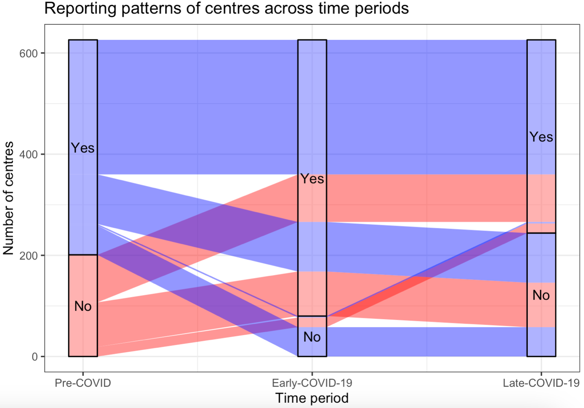

In the Pre-COVID-19 period, each centre can either report, or not report data to the ELSO registry. As time passes and we enter the early-COVID-19 period, there were 182 centres which started reporting data to the ELSO registry (transitioning from “No” to “Yes”), and 61 centres which stopped reporting data (transitioning from “Yes” to “No).

From the early-COVID-19 period to the late-COVID-19 period, an additional 22 centres started reporting data to the registry, and 186 centres stopped reporting data. Of the 182 centres which started reporting data during the early COVID-19 period, only 94 centres continued reporting data during the late-COVID-19 period.

# Figure S3. Trends in centre volume across time periods stratified by ELSO chapter

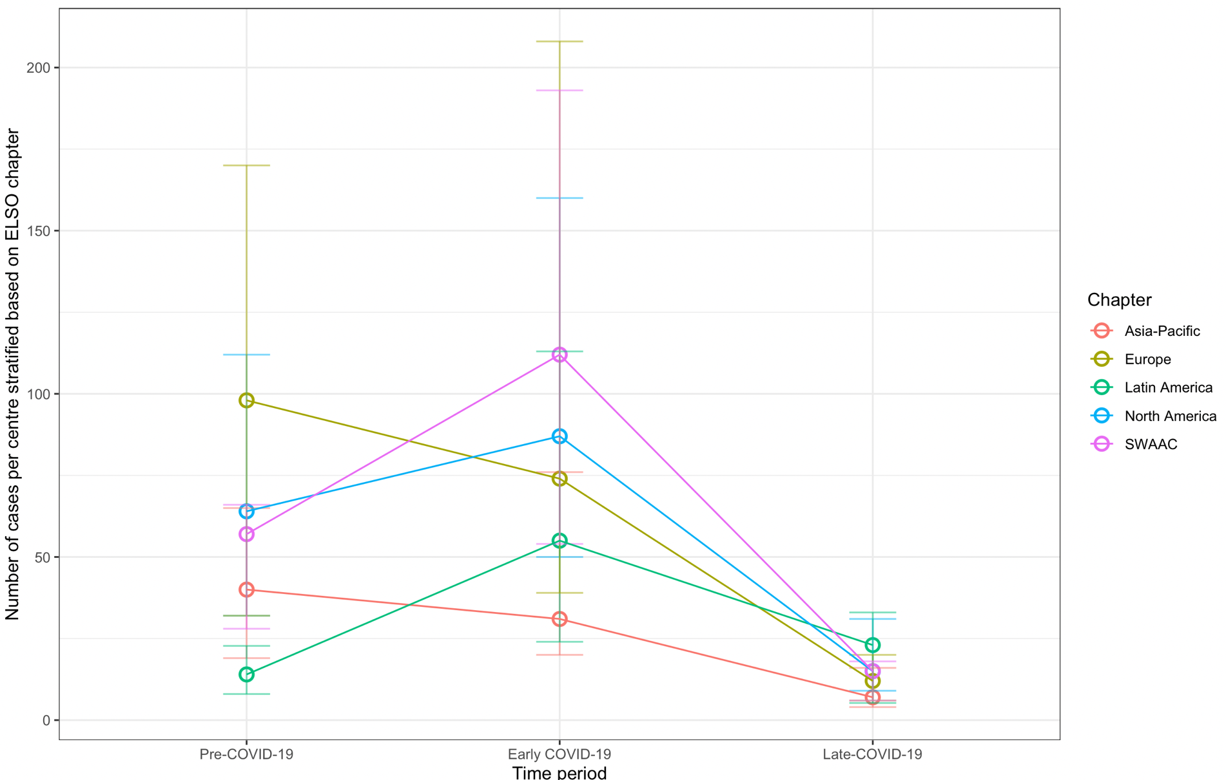

# Table S3. Demographics, centre, and pre-ECMO characteristics across the three time periods

|  |  |  |  |  |  |  |  |
| --- | --- | --- | --- | --- | --- | --- | --- |
| **Era** | **Pre-COVID-19** | **COVID-19** | **Post COVID-19** | **P-value** | **P-value**  **(A vs B)** | **P-value**  **(A vs C)** | **P-value**  **(B vs C)** |
| Participants | 11453 | 22004 | 3231 |  |  |  |  |
| Age (years) | 49.5 (35.6-60.5) | 48.1 (37.1-57.6) | 48.5 (34.2-60.6) | <0.0001 | <0.0001 | 0.15 | 0.12 |
| Weight (kg) | 84.0 (70.0-103.0) | 90.0 (75.8-109.0) | 84.9 (70.0-102.9) | <0.0001 | <0.0001 | 0.41 | <0.0001 |
| Height (cm) | 170.0 (162.6-178.0) | 170.2 (164.0-178.0) | 170.2 (163.0-178.0) | <0.0001 | <0.0001 | 0.10 | 0.18 |
| BMI (kg/m2) | 28.6 (24.2-34.6) | 30.9 (26.3-36.5) | 29.0 (24.5-34.5) | <0.0001 | <0.0001 | 0.13 | <0.0001 |
| **Sex (count [%])** | | | | |  |  |  |
| Female | 4341 (37.8%) | 7348 (33.4%) | 1232 (38.2%) | <0.0001 | <0.0001 | 0.98 | <0.0001 |
| Male | 7037 (61.4%) | 14647 (66.5%) | 1998 (61.8%) |
| **Centre characteristics** | | | | | | | |
| Number of centres | 425 | 546 | 382 |  |  |  |  |
| Centre volume | 20.67 (9.67-37.3) | 28 (15.67-52) | 15 (8-26) | <0.0001 | <0.0001 | <0.0001 | <0.0001 |
| **Pre-ECMO/ECMO characteristics** | | | | | | | |
| Time from admission to intubation | 0 (-18 to 32) | 0 (-48 to 70) | 1 (-14-56.5) | <0.0001 | <0.0001 | <0.0001 | <0.0001 |
| Time from intubation to ECMO | 26 (7-94) | 54 (12-133) | 21 (6-90.5) | <0.0001 | <0.0001 | <0.0001 | <0.0001 |
| Duration of ECMO | 7.7 (3.9-14.2) | 13.6 (6.0-27.7) | 7.0 (3.6-13.9) | <0.0001 | <0.0001 | 0.0066 | <0.0001 |
| Duration of survival time post-ECMO until final disposition or death | 8.8 (0.04-22.1) | 6.7 (0-21.0) | 8.1 (0.04-21.2) | <0.0001 | <0.0001 | 0.16 | <0.0001 |
| COVID-19 addendum | 0 (0%) | 13005 (59.1%) | 180 (5.6%) | <0.0001 | <0.0001 | <0.0001 | <0.0001 |

# Table S4. Arterial blood gas before and after ECMO initiation

|  |  |  |  |  |  |  |  |
| --- | --- | --- | --- | --- | --- | --- | --- |
| **Era** | **Pre-COVID-19** | **COVID-19** | **Post COVID-19** | **P-value** | **P-value**  **(A vs B)** | **P-value**  **(A vs C)** | **P-value**  **(B vs C)** |
| **Pre-ECMO arterial blood gas\*** | | | | | | | |
| pH | 7.24 (7.15-7.34) | 7.28 (7.19-7.36) | 7.27 (7.17-7.35) | <0.0001 | <0.0001 | <0.0001 | <0.0001 |
| PaCO2 | 58.0 (47.0-75.0) | 60.0 (48.8-74.8) | 56.0 (45.4-70.0) | <0.0001 | <0.0001 | <0.0001 | <0.0001 |
| PaO2 | 67.0 (54.0-85.5) | 67.0 (56.0-84.0) | 70.0 (58.0-98.0) | <0.0001 | 0.12 | <0.0001 | <0.0001 |
| PaO2/FiO2 ratio | 70.5 (55.0-100.7) | 71.0 (57.0-94.0) | 75.0 (59.0-117.0) | <0.0001 | 0.63 | <0.0001 | <0.0001 |
| **Post-ECMO arterial blood gas\*\*** | | | | | | | |
| pH | 7.40 (7.35-7.44) | 7.40 (7.36-7.44) | 7.40 (7.36-7.44) | 0.0011 | 0.0042 | 0.65 | 0.020 |
| PaCO2 | 41.2 (37.0-46.7) | 44.0 (39.0-50.7) | 42.0 (37.0-47.0) | <0.0001 | <0.0001 | <0.0001 | 0.037 |
| PaO2 | 83.0 (68.0-111.2) | 77.0 (65.0-98.2) | 88.1 (71.0-122.0) | <0.0001 | <0.0001 | <0.0001 | <0.0001 |
| PaO2/FiO2 ratio | 172.6 (112.8-255.0) | 156.9 (102.5-222.5) | 185.0 (122.4-268.0) | <0.0001 | <0.0001 | <0.0001 | <0.0001 |

Abbreviations: PaO2: arterial partial pressure of oxygen, PaCO2: arterial partial pressure of carbon dioxide, FiO2: fraction of inspired oxygen

*Defined as the arterial blood gas closest to and not more than 6 hours before ECMO initiation

**Defined as the arterial blood gas drawn between 18 to 30 hours after ECMO initiation, closest to 24 hours after initiation of ECMO

# Table S5. Ventilatory parameters before and after ECMO initiation, across time periods

|  |  |  |  |  |  |  |  |
| --- | --- | --- | --- | --- | --- | --- | --- |
| **Era** | **Pre-COVID-19** | **COVID-19** | **Post COVID-19** | **P-value** | **P-value**  **(A vs B)** | **P-value**  **(A vs C)** | **P-value**  **(B vs C)** |
| **Pre-ECMO ventilatory parameters** | | | | | | | |
| Rate | 24.0 (18.0-28.0) | 26.0 (20.0-30.0) | 24.0 (18.0-28.0) | <0.0001 | <0.0001 | 0.92 | <0.0001 |
| PIP | 33.0 (29.0-38.0) | 33.0 (29.0-38.0) | 33.0 (28.0-37.8) | 0.0055 | 0.31 | 0.024 | 0.0036 |
| PEEP | 12.0 (10.0-15.0) | 12.0 (10.0-15.0) | 10.0 (8.0-14.0) | <0.0001 | 0.011 | <0.0001 | <0.0001 |
| Inflation pressure | 20.0 (16.0-26.0) | 20.0 (16.0-25.0) | 21.0 (16.0-26.0) | 0.0007 | 0.40 | 0.0007 | 0.0007 |
| **Post-ECMO ventilatory parameters** | | | | | | | |
| Rate | 12.0 (10.0-16.0) | 12.0 (10.0-16.0) | 12.0 (10.0-16.0) | 0.30 | 0.43 | 0.43 | 0.82 |
| PIP | 24.0 (20.0-28.0) | 24.0 (21.0-28.0) | 24.0 (20.0-27.0) | <0.0001 | 0.98 | <0.0001 | <0.0001 |
| PEEP | 10.0 (8.0-12.0) | 10.0 (10.0-12.0) | 10.0 (8.0-10.0) | <0.0001 | <0.0001 | <0.0001 | <0.0001 |
| Inflation pressure | 14.0 (10.0-18.0) | 13.0 (10.0-17.0) | 14.0 (10.0-17.0) | 0.27 | 0.31 | 0.66 | 0.66 |

Abbreviations: PIP: peak inspiratory pressure, PEEP: positive end-expiratory pressure

*Defined as the ventilatory parameters/settings closest to and not more than 6 hours before ECMO initiation

**Defined as the ventilatory parameters/settings between 18 to 30 hours after ECMO initiation, closest to 24 hours after initiation of ECMO

# Table S6. Pre-ECMO adjunctive therapies

|  |  |  |  |  |  |  |  |
| --- | --- | --- | --- | --- | --- | --- | --- |
| **Era** | **Pre-COVID-19** | **COVID-19** | **Post COVID-19** | **P-value** | **P-value**  **(A vs B)** | **P-value**  **(A vs C)** | **P-value**  **(B vs C)** |
| Nitric oxide | 2433 (25.6%) | 6180 (31.0%) | 780 (27.6%) | <0.0001 | <0.0001 | 0.043 | 0.0004 |
| Steroids | 1932 (20.4%) | 7584 (38.0%) | 793 (28.0%) | <0.0001 | <0.0001 | <0.0001 | <0.0001 |
| Bicarbonate or THAM | 1468 (15.5%) | 1869 (9.4%) | 441 (15.6%) | <0.0001 | <0.0001 | 0.91 | <0.0001 |
| CVVH | 1159 (12.2%) | 1474 (7.4%) | 291 (10.3%) | <0.0001 | <0.0001 | 0.0057 | <0.0001 |
| Neuromuscular blockade | 5554 (58.5%) | 13670 (68.5%) | 1524 (53.9%) | <0.0001 | <0.0001 | 0.038 | 0.028 |
| Vasodilators | 162 (1.7%) | 140 (0.7%) | 32 (1.1%) | <0.0001 | <0.0001 | <0.0001 | <0.0001 |
| Prone positioning | 1355 (14.3%) | 8551 (42.8%) | 489 (17.3%) | <0.0001 | <0.0001 | <0.0001 | <0.0001 |

Abbreviations: THAM: tris-hydroxymethylaminomethane, CVVH: continuous venovenous hemofiltration

# Table S7. Unadjusted survival estimates at 90 days after ECMO initiation across time periods, and annually

|  |  |  |
| --- | --- | --- |
| **Covariate** | **Survival** | **95%-CI** |
| Pre-COVID-19 | 64.9% | 64.0%-65.8% |
| COVID-19 | 58.4% | 57.7%-59.1% |
| Post-COVID-19 | 65.1% | 63.5%-66.7% |
| **By Year** | | |
| 2017 | 63.0% | 61.3%-64.7% |
| 2018 | 64.2% | 62.7%-65.7% |
| 2019 | 66.7% | 65.3%-68.1% |
| 2020 | 57.1% | 56.0%-58.2% |
| 2021 | 57.1% | 56.1%-58.1% |
| 2022 | 63.4% | 61.9%-64.9% |
| 2023 | 65.1% | 63.5%-66.7% |

# Table S8. Complications while receiving ECMO

|  |  |  |  |  |  |  |  |  |  |  |
| --- | --- | --- | --- | --- | --- | --- | --- | --- | --- | --- |
| **Era** | **Pre-COVID-19** | | **COVID-19** | | **Post COVID-19** | | **P-value\*\*** | **P-value**  **(A vs B)** | **P-value**  **(A vs C)** | **P-value**  **(B vs C)** |
| Proportion | Rate* | Proportion | Rate* | Proportion | Rate* |
| Mechanical*** | 1995 (17.4%) | 0.91 | 6021 (27.4%) | 0.69 | 567 (17.5%) | 0.91 | <0.0001 | <0.0001 | 0.24 | <0.0001 |
| Haemorrhagic | 1634 (14.3%) | 0.75 | 3172 (14.4%) | 0.36 | 349 (10.8%) | 0.56 | <0.0001 | <0.0001 | <0.0001 | 0.015 |
| Renal | 3386 (29.6%) | 1.55 | 6440 (29.3%) | 0.73 | 901 (27.9%) | 1.44 | <0.0001 | <0.0001 | 0.47 | <0.0001 |
| Pulmonary | 801 (7.0%) | 0.37 | 2803 (12.7%) | 0.32 | 265 (8.2%) | 0.43 | <0.0001 | <0.0001 | 0.0029 | <0.0001 |
| Cardiovascular | 1606 (14.0%) | 0.74 | 2715 (12.3%) | 0.31 | 361 (11.2%) | 0.58 | <0.0001 | <0.0001 | 0.0003 | 0.19 |
| Metabolic | 834 (7.3%) | 0.38 | 1910 (8.7%) | 0.21 | 259 (8.0%) | 0.41 | 0.11 | 0.21 | 0.13 | 0.21 |
| Infectious | 428 (3.7%) | 0.20 | 315 (1.4%) | 0.04 | 28 (0.9%) | 0.04 | <0.0001 | <0.0001 | <0.0001 | 0.10 |
| Limb | 136 (1.2%) | 0.06 | 202 (0.9%) | 0.02 | 36 (1.1%) | 0.06 | 0.0010 | 0.0016 | 0.97 | 0.084 |

*Number of complications per 1000 hours of ECMO run.

**P-values in this table compare between the proportion of patients who suffer from a complication.

***Complications have been grouped into broad categories in accordance with the ELSO registry.